|  |  |  |
| --- | --- | --- |
| **Name** | **ID** | **STUDENT SIGN** |
| **Amit Podder** | **20-42273-1** | **Amit** |

**Class Test 02**

1. **Below a scenario has been given draw the ER Diagram.**

***Draw with proper annotations (use DIA, VISIO, MS WORD, etc.)*** ***For reference see ER Diagram Tutorial***

In an Ice-Cream Parlor, a customer may buy or order many ice-creams. Each customer has a unique customer id. Customer data such as customer name, phone number, card no, and total purchase amount are also stored in the system. A customer can have multiple cards. An ice cream can only be sold to or ordered by only one customer. When buying a unique transaction ID and date are stored. When ordering an order, no and delivery date is stored. The ice creams are identified by their names. The cost price, sell price, profit, stock, flavor, and manufacturer information is available in the system. The profit is calculated from the cost price and the selling price. Ice-creams are sold by employees, where each ice cream can be sold by one employee but one employee can sell many ice-creams. Each employee is identified by their unique employee id. The system also has the employee’s name, shift, salary, hire date, phone no, address, and NID stored. Each employee works under only one manager and one manager oversees all employees of a branch. A manager works in only one branch. They have their unique employee ID and their name, salary, hire date, phone no, address, NID is stored in the database. Managers and employees can have multiple phone numbers. Each branch has one manager. And each branch has a location and is identified by its unique branch no. All branches are outlets of one company. The company has a unique trade license no and opening date and location. Each branch has its single account and the company has a single account. In the accounts, daily profit, net profit, and balance are stored. Each of the branch’s net profit is calculated from the ice-creams profit and the company’s net profit is calculated from all of the branch’s net profit. The whole company is owned by multiple owners. Among the owners, there is a founder. Each of the owners is identified by their NID. Other data such as name, phone no, and email are also stored in the database. The owners can have multiple phone no.

**Answer 1:**



1. **Below an ER Diagram has been given to write the scenario.**

***For reference see ERDiagramTutorial.***

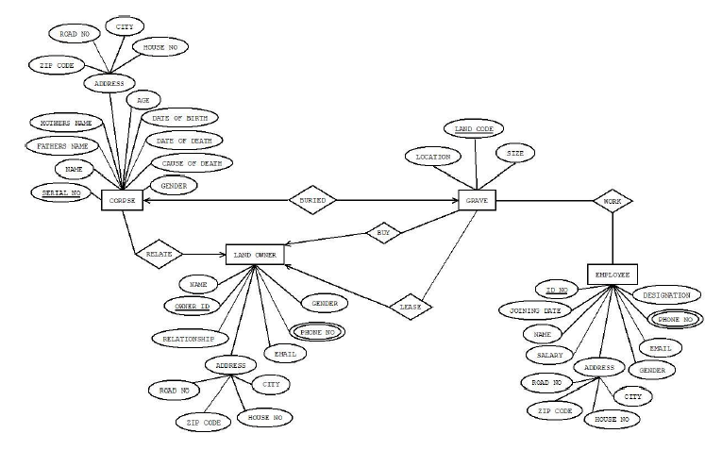

**Answer 2:**

Corpses can have their serial no, name, father’s name, mother’s name, address, zip code, road no, city, house no, age, date of birth, date of death, cause of death, and gender. Another corpse can be buried in one grave. It has location, land code, and size. A corpse can have many landowners. It has a name, NID, relationship, Email, multiple phone no, gender, and address including zip code, road no, city, and house no. The landowner can lease many graves. There are employees. It has its ID no, name, salary, address, road no, Zip code, city, house no, gender, email, and designation. It can have multiple phone numbers.